

**A_CRM_Application_for_Schools&Colleges**

**1.INTRODUCTION**

1.1OVERVIEW

CRM solutions are used by schools to streamline admission workflows, manage marketing messages, and handle admission processes (follow-ups, open houses, grants, etc.). It is a piece of software used to handle and automate communication with current customers, staff members, and alumni. This entire process takes place on a single system.

1.2 PURPOSE

CRM Prepares Colleges and Universities for Whatever is Next.

A CRM platform connects insights campus-wide instead of creating data silos, making it easier for institutions to quickly support new business models as constituent needs evolve over time.

1. **Problem Definition & Design Thinking** 
   1. Empathy Map

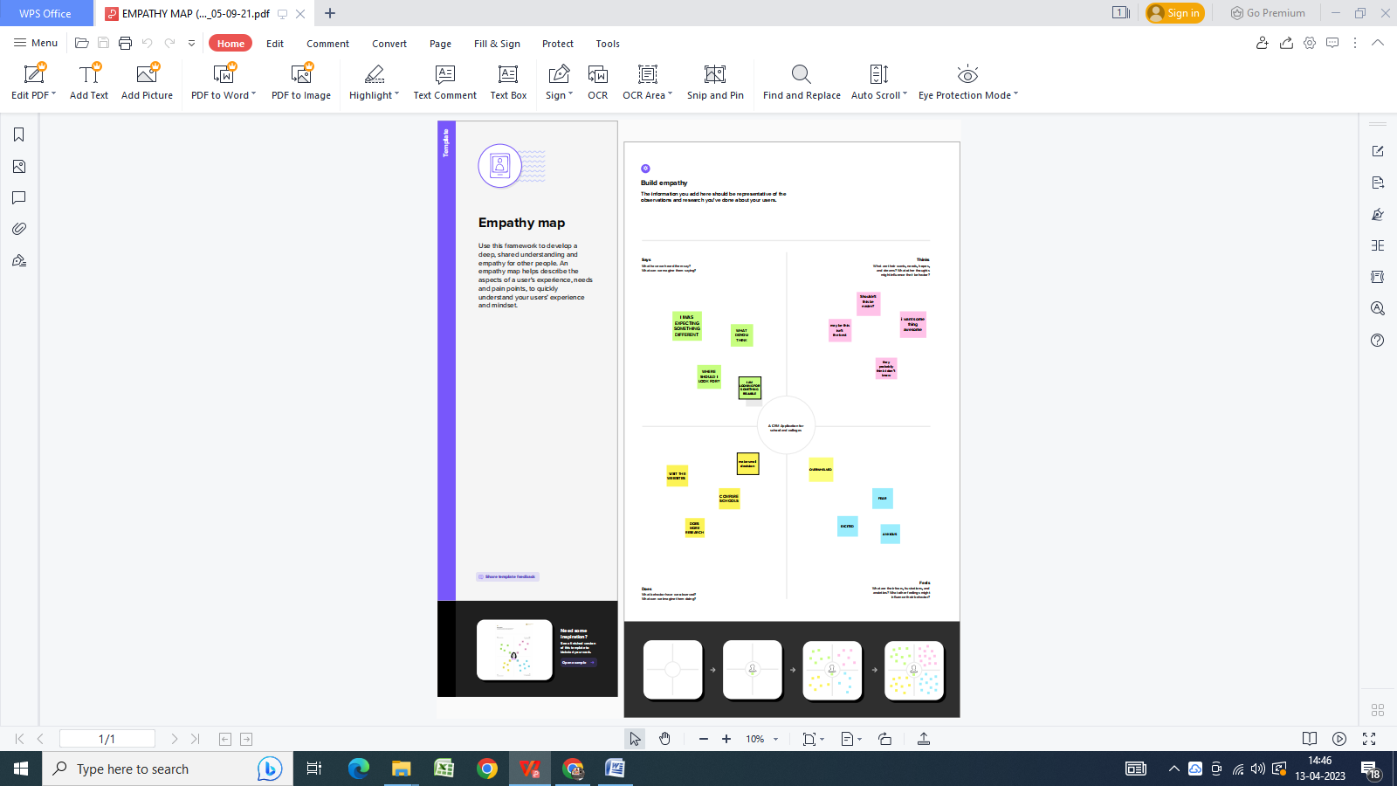

* 1. Ideation & Brainstorming Map

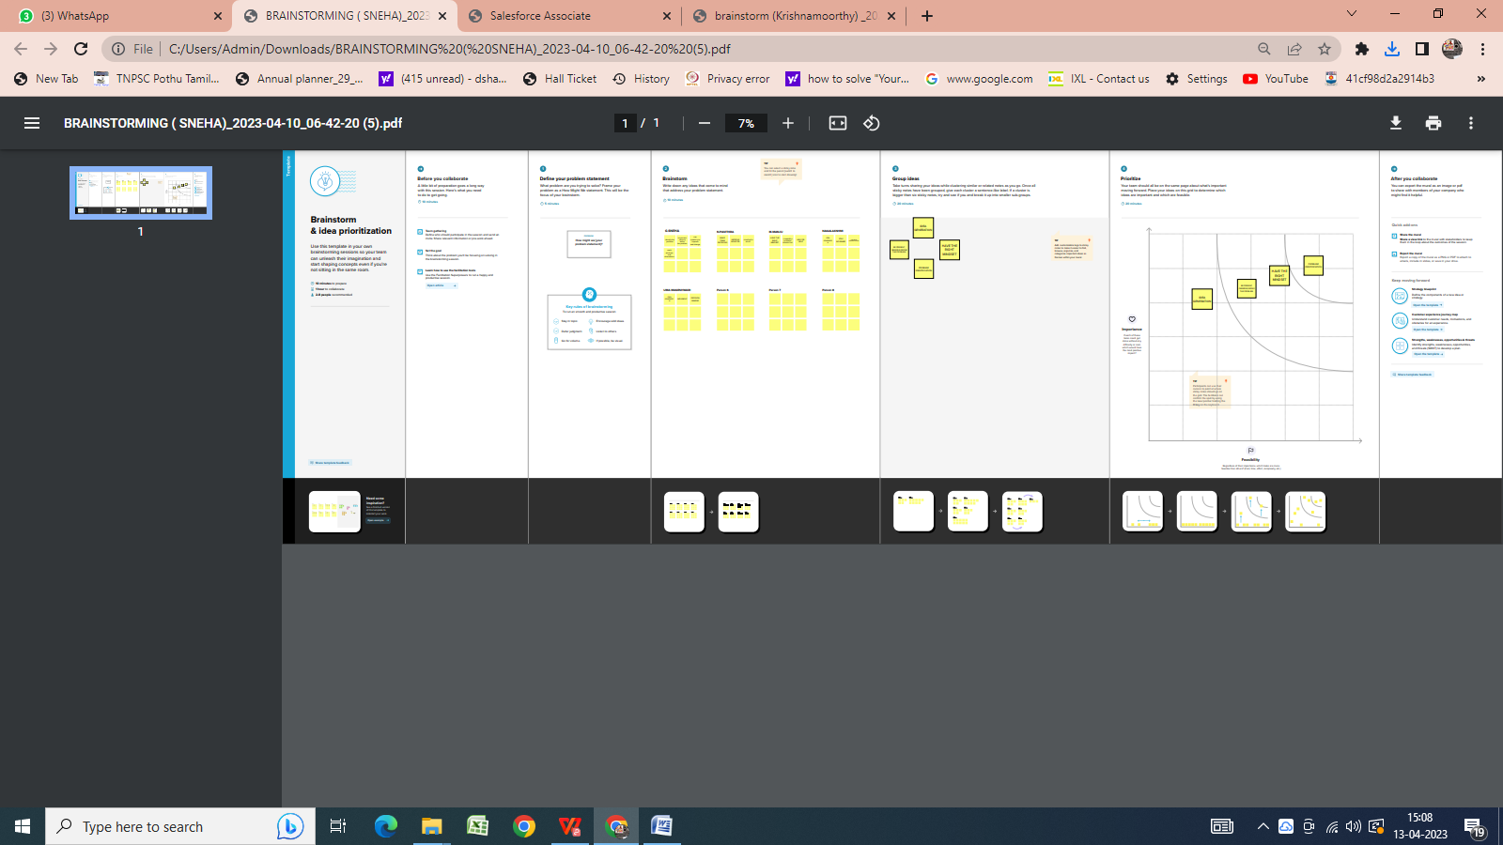

1. **RESULT** 
   1. Data Model:

|  |  |  |
| --- | --- | --- |
| **Object name** | **Fields in the Object** | |
| obj1 | Field label | Data type |
| School | Address | Text area |
| school | Number of Students | Roll up summary fields |
|  |  |  |
| Obj2 | Field label | Data type |
| Student | Phone Number | Phone |
| Student | Results | Picklist |
|  |  |  |

* 1. Activity & Screenshot 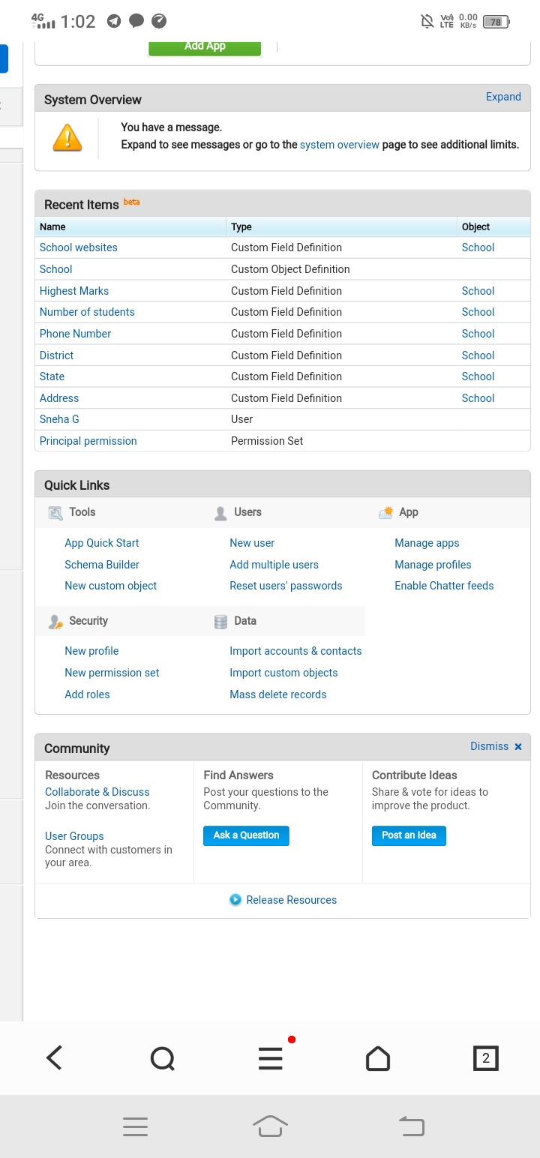

1. **Trailhead Profile Public URL**

**Team Lead -** [**https://trailblazer.me/id/pedits3**](https://trailblazer.me/id/pedits3)

**Team Member 1 –** [**https://trailblazer.me/id/snehg12**](https://trailblazer.me/id/snehg12)

**Team Member 2 –** [**https://trailblazer.me/id/nnagalakshmi9**](https://trailblazer.me/id/nnagalakshmi9)

**Team Member 3** – <https://trailblazer.me/id/umagi>

**Team Member 4** – <https://trailblazer.me/id/vtfeup3x>

1. **ADVANTAGES & DISADVANTAGE**

* Reduction in the cost of expenses. ...
* Improving the quality of service / product. ...
* Improving the organization management process. ...
* Increased customer loyalty. ...
* Track and increase the number of potential clients. ...
* History of work with each student...

1. **APPLICATIONS**

CRM systems are computer programmes that are used to manage and automate communications with contributors, staff, alumni, and students both past and present.

1. **CONCLUSION**

By seeing them as valuable customers with valuable input, a CRM software for educational institutions enhances communication among student networks. It is used by institutions for MIS reports, admissions processes, and the expert administration of the student life cycle....

1. **FUTURE SCOPE**

* Learn how CRM for higher education enables colleges and universities to manage relationships with students, alumni, faculty, staff, and partners in one...